**Digital Nurture 4.0 Java FSE**

**Week 7 ReactJS - HOL**

**Mandatory Exercise (HandsOn 12)**

**Exercise 12:**

Create a React Application named “ticketbookingapp” where the guest user can browse the page where the flight details are displayed whereas the logged in user only can book tickets.

The Login and Logout buttons should accordingly display different pages. Once the user is logged in the User page should be displayed. When the user clicks on Logout, the Guest page should be displayed.

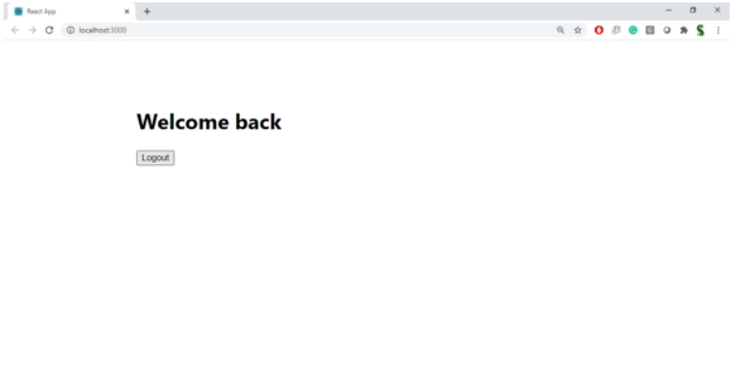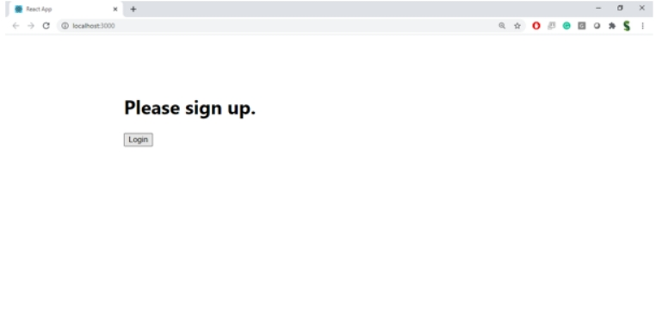

**Hint:**

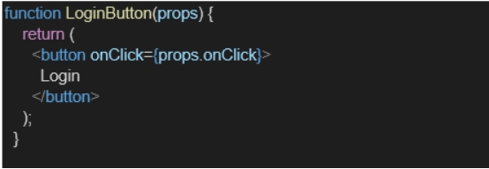

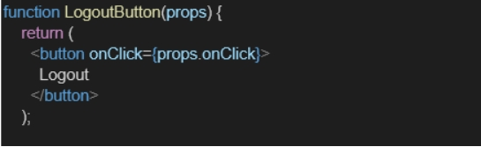

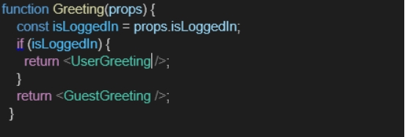

**Answer:**

**GuestPage.js:**

import React from 'react';

const GuestPage = () => {

  return (

    <div>

      <h2>Welcome Guest!</h2>

      <p>Browse available flights below:</p>

      <ul>

        <li>Flight A123 - Chennai to Delhi - ₹4500</li>

        <li>Flight B456 - Mumbai to Bangalore - ₹3200</li>

        <li>Flight C789 - Kolkata to Hyderabad - ₹3900</li>

      </ul>

      <p>Please login to book tickets.</p>

    </div>

  );

};

export default GuestPage;

**UserPage.js:**

import React from 'react';

const UserPage = () => {

  return (

    <div>

      <h2>Welcome Back!</h2>

      <p>You can now book your tickets:</p>

      <ul>

        <li>Flight A123 - <button>Book</button></li>

        <li>Flight B456 - <button>Book</button></li>

        <li>Flight C789 - <button>Book</button></li>

      </ul>

    </div>

  );

};

export default UserPage;

**App.js:**

import React, { useState } from 'react';

import GuestPage from './GuestPage';

import UserPage from './UserPage';

function App() {

  const [isLoggedIn, setIsLoggedIn] = useState(false);

const handleLogin = () => setIsLoggedIn(true);

  const handleLogout = () => setIsLoggedIn(false);

  return (

    <div className="App">

      <h1> Ticket Booking App</h1>

      <div>

        {isLoggedIn ? (

          <>

            <button onClick={handleLogout}>Logout</button>

            <UserPage />

          </>

        ) : (

          <>

            <button onClick={handleLogin}>Login</button>

            <GuestPage />

          </>

        )}

      </div>

    </div>

  );

}

export default App;

**App.css:**

.App {

  text-align: center;

  font-family: sans-serif;

  padding: 20px;

}

button {

  margin: 10px;

  padding: 10px 20px;

  font-size: 16px;

}

**Output:**

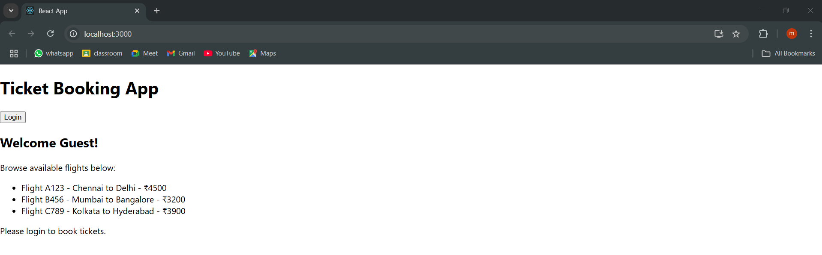**Given own location details for booking**





